


Project no. 034595

SELF
Science, Education and Learning in Freedom

Instrument: SSA - Specific Support Action
Thematic Priority: IST-2005-2.5.5 – Software and Services

Deliverable D5
SELF Platform Development:
System design and representation and beta release

Period covered: Date of preparation:
from July 1st, 2006 to 30th May 2007 31th May 2007

Start date of project: Duration:
July 1st, 2006 2 years

Organisation name of lead contractor for this IR
Homi Bhabha Center for Science Education Revision draft v0.6
Nagarjuna G.

Project co-funded by the European Commission within the Sixth Framework Programme (2002-2006)
Dissemination Level
PU | Public | PU
PP | Restricted to other programme participants (including the Commission Services)
RE | Restricted to a group specified by the consortium (including the Commission Services)
CO | Confidential, only for members of the consortium (including the Commission Services)

Table of Contents
Acknowledgements 4
1 Introduction 5
2 Software Selection for the Platform 7
2.1 ZOPE 7
2.2 Plone 8
3 GNOWSYS 9
3.1 Technical specification of GNOWSYS 9
3.2 Change Management in GNOWSYS 12
3.3 GNOWSYS for the SELF Platform 16
4 Translating Platform Definition into Implementation Design 17
4.1 Creation of the Initial Knowledge Base and Basic Data Model 17
4.2 Authoring System 22
4.2.1 Creating Content Items 23
4.3 Shelf Management 29
4.4 Collaboration 30
4.5 Harvesting 30
4.5.1 Semi-automatic Harvesting 31
4.5.2 Manual Harvesting 31
4.6 Atomiser 31
4.7 Course Organization, Sequencing and Navigation Definition For the SELF Platform 33
4.7.1 Default Sequence and Navigation 33
4.7.2 Advanced (Adaptive) Sequence, Navigation and Rollup 34
4.7.3 Classification of Resources 39
4.8 Version Control 43
4.8.1 Keeping history 43
4.8.2 Tracking and Record Keeping 43
4.8.3 Comparing versions 44
4.8.4 Branching 44
4.9 Rating and Crediting System 44
4.10 Translation 45
4.10.1 Content 45
4.10.2 Metadata 46
4.10.3 User Interface 46
4.11 Search 46
4.11.1 Catalogue 47
4.11.2 Advanced (semantic) 47
4.12 Delivery 47
4.12.1 Default 47
4.12.2 HTML 47
4.12.3 SCORM 48
4.12.4 LaTeX 48
4.12.5 PDF 48
4.12.6 ODT 48
4.12.7 Docbook 48
4.13 Distributed knowledge base 48
4.14 p2p service architecture 48
4.15 Accessibility 49
5 Glossary 51

Acknowledgements
This document has been collaboratively written by the SELF Project team. The Team has held many discussions on various alternatives of shaping the Platform, and implementation details. The team mainly consisted of: Federico Heinz, Meena Kharatmal, Dragoslava Pefeva, David Jacovkis, Nagarjuna G., Prasanta Barua, Bipin Apandkar, Debarshi Ray, Rakesh Pandit, Wouter Tebbens, and David Megias. All participants are gratefully thanked for their valuable inputs, in particular we thank Vedran Vucic and Machtelt Garrels for their active participation. A student of Symbiosis Institute of Computer Studies & Research, Pune, who worked with Nagarjuna as an intern during the last winter, Ms. Divya, who did the import and export module of SCORM into GNOWSYS knowledge base, must be made a special mention. She painstakingly studied the SCORM specification and did a pilot version of the scripts, which are being updated for the SELF project.

Introduction
One of the most important functions of the SELF Platform is to facilitate collaborative course development in an online environment. It is an author-centric platform for developing learner-centric content. While translating the high level specifications of the platform into an implementable design, one of the main factors kept in mind is to keep the authors in the centre of the platform and to think around them. The SELF Platform is like a stage, on which the main actors are authors, and they together collaboratively create courses.
The SELF Platform's development was concieved at a time when so much of experience was already gained within the free software community in building such web based applications. The existing free e-learning applications, Moodle and Atutor are centered around the student, even though theyhave an authoring system in place. Keeping this experience in mind, if there is any reason to develop another application, instead of using them directly, it is in order to provide some features that the authors need. Free e-learning environments have already matured as delivery applications, and are increasingly being used around the world. They are, in a technical sense, good free run time environments (RTE) for LOM, SCORM and IMS compliant, in various degrees, electronic course materials. The focus of the SELF project is not a RTE, but an easy to use, community based portal for harvesting free content from all possible sources, and collaboratively author and develop the existing content, and become a resource base for course material. Although our initial focus is to develop content for Free Software and Open Standards, the SELF Platform is independent of content, and therefore can be used for any subject.
Having made the implementation focus clear, the next step is to learn from the existing state-of-the-art. Among the most successful collaborative authoring experiments in the history of Internet is obviously the Wikipedia. To risk a parallel, the SELF Platform is to FreeCourseWare, as Wikimedia is to Wikipedia. As platform to share knowledge, and collaboratively author content, the wikipedia project demonstrated to the world not only how technology can be shaped together, but also how technology can be shaped to support the culture of sharing. Simplicity of authoring, ability to track each individual change, negotiation among the authors, made Wikipedia a very successful project. While making the SELF Platform, we keep this goal in mind: shape the technology to support the collaboration among authors, teachers and students.
Other examples that come to mind are Gforge, free software similar to the software project development of sourceforge. Gforge is used, for example, by the GNU project at Savannah - the free software repository. Such projects are very good examples of supporting collaborative software development, integrating the entire lifecyle of an application. We intend to do something similar for managing the course authoring projects.
We kept these major legacy application design in mind while implementing the Platform.
In this document we will describe the main architecture of the SELF Platform and the implementation of the SELF Platform Definition (the high-level specs). The current release of the system can be found as a registered project in Savannah. An online demonstration of this release is set up and will be updated as soon as newer releases come out.

Software Selection for the Platform
The SELF Platform has the following software requirements:
- A Secure Web Server
- A Web Application Framework
- A Database
- A Content Management System
- A Version Control System
- A search engine
- An agent-oriented and semantic-web enabled platform
- An Authoring System for creating packages that work in a LMS (Learning Management System)
- An LMS.
It is very unlikely that we can find one single application among the free software that is already available, which will perform all the above mentioned tasks. However, there do exist application development frameworks that support extensions to existing products so as to obtain all the features easily packaged into one. Keeping this in mind we selected ZOPE (see the following section for details) to be the main web publishing platform. This choice, among other reasons, is also based on the development team's knowledge and experience.

ZOPE
ZOPE (Zee Object Publishing Environment) provides a mechanism for publishing objects (instances of Classes usually written in Python) as web services. It is widely used all over the world and is actively developed and maintained. ZOPE provides the following features:
- web based management
- an object oriented database
- all major web service protocols (HTTP, FTP, WebDav, XMLRPC, SOAP etc.)
- inbuilt HTTP Server (can be integrated with Apache or other HTTP servers)
- powerful templates for dynamic content (ZPT, DTML)
- Connectors to Relational Database
- Powerful Content Management Framework

By inheriting the existing features and products of ZOPE, extending some other applications, it is indeed possible to develop the SELF Platform with all the major features mentioned above as a product of ZOPE. Thus in a sense, several of the required features come to us almost ready to use on top of the ZOPE Platform.

ZOPE's web service infrastructure for publishing the knowledge base generated by the SELF Platform is very useful in implementing the distributed knowledge base (see the section on GNOWSYS). Every published object of the knowledge base is provided by a URL. This helps in using an object independent of the others from any where on the Internet.

Plone
Plone is arguably the most popular product of ZOPE, which is widely used all over the world for content management. It is an extension of the CMF (Content Management Framework) offered by ZOPE. We use the powerful Archetypes tool of Plone to define two main content objects in the SELF Platform (learning object type and its instnce learning object) for managing the content. Another feature that we will use extensively from Plone is the integrated CSS rendering, and placeless translation service for internationalization.
SELF Platform therefore depends on the availability of Plone, and in turn on ZOPE.

GNOWSYS
GNOWSYS (Gnowledge Networking and Organizing SYStem) is a generic specification for a knowlede representation scheme. GNOWSYS, being generic, can comply with multiple knowledge representation standards such as OWL, XTM, CL, etc. The generality of GNOWSYS enables easy data exchange from one standard model to another. The current specification is implemented as a product of ZOPE (Zee Object Publishing Environment). GNOWSYS is free software and an official GNU project. Its development is currently supported by the Homi Bhabha Centre for Science Education, TIFR.
Since GNOWSYS will keep the entire metadata of the content published in Plone, and is not widely used application, we will give the details below.

Technical specification of GNOWSYS
The GNOWSYS specification suggests to have 20 storage classes (tables) of which 19 of them provide core knowledge representation scheme. But as a distributed networking database, all the 19 core classes are specified as nodes of the networking model. For the implementation of the SELF Platform, we use only ten of the regular classes, since the data model of the SELF Platform does not need the procedural representation and process modelling. These additional classes can be used optionally if necessary, say if SELF Platform is extended in future to include the Run Time Environment, so that it supports delivery of the courses to students. In this document we will not make any further mention of the classes other than the ten required classes.
The knowledge base can be implemented in any database, for GNOWSYS is an implementation-independent specification. For the SELF Platform we will use Zope for Phase I. And as the specification of the Platform freezes, the storage will be made in PostgreSQL, an object-relational database, which will also ensure stability and scalability of large size knowledge bases.

The core classes of GNOWSYS are organized in three layers as shown in the Illustration below.
The nodes are networked among three kinds of nodes: declarative, procedural and agent. Agent objects are further divided into User Type and User. User Type is used to categorize its User instances, which act as proxy objects for real users. Declarative objects are frames that store the metadata of the objects. Procedural objects are proxy objects which when invoked execute the specified procedures.

Illustration 1: The twenty classes (node types) of GNOWSYS which are used to represent knowledge. Instances of each class are the nodes which get linked to each other to form a network. These are grouped, as shown in the illustration as tokens, types and metatypes. Based on what each of them stand for, they are further classified as agentive, declarative and procedural.
Agent
usertype
user
Procedural
pclass
flowtype
functiontype
pobject
flow
function
metatypes
Metatypes
Types
Tokens
processtype
Declarative
dclass
systemtype
relationtype
attributetype
dobject
system
process
relation
attribute

The following figures describe the structure of the classes (Node Types). Using this specification, we can implement them as object oriented classes, or since declarative nodes do not have any methods associated with them, they can be implemented as tables in a relational database.

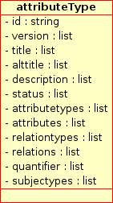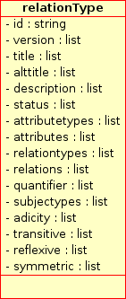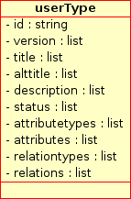
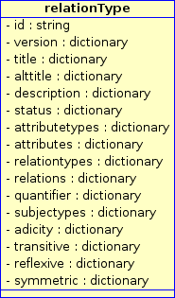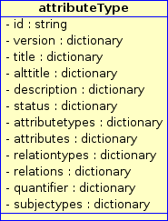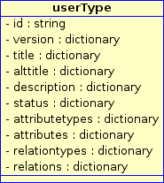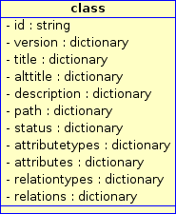

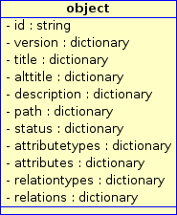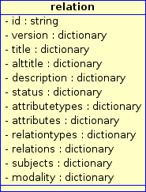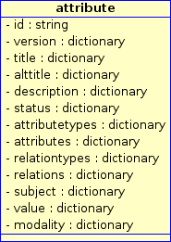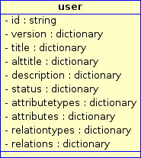

llustration 2: Most widely used GNOWSYS Node Types for the SELF Platform. Another upper ontology Node Type, called Metatype, is not included in the illustration, for its structure is similar to Class. All the above types can be made instances of the Metatype. The bottom row shows the instances of the Node Types. Each Node acts as a frame keeping its neighborhood information to generate the organization and networking of the distributed elements of a knowledge base. System and System type will be used for organizers, sequencing, defining adaptive navigation, rollup conditions, sequencing actions etc. These two node types will have an additional field called 'structure', in addition to what the node types class and object have.

Change Management in GNOWSYS
GNOWSYS is made for collaborative web based authoring of knowledge applying with semantics. Unlike collaborative software development, where hackers check out a development version from change management systems like cvs, svn, GNU arch, and make changes in a standalone editor, and frequently makes committs once they have reached a landmark, in this situation, the version control system is required to have only the versions of various committs that each user makes. However, in the case of a collaborative web based authoring, the authors are generally using a client application (normally a browser), and each modification made can also be part of the history. This is a special requirement of the version management of web applications.

The knowledge base of GNOWSYS is complex, but follows a specified (predefined) structure. One aspect of the specification is that each node has a fixed number of fields in any given release of GNOWSYS. This feature enables us to define a version management scheme that manages to keep every change economically. The structured granularity will also be very useful in mirroring different instances of the knowledge base.

Each node in the network has a neighbourhood of nodes, and the specification clearly defines what kind of node will have what kind of objects in the neighbourhood. For example, an object node will have the following fixed kind of objects in the neighbourhood: relations, relation types, attributes, and attribute types. Maintaining versions of each node, and the metadata associated with each is a challenging task. The relevance of this feature is very high if the application is to be used as a community portal with collaborative work cycles. Since GNOWSYS is particularly meant for sharing, collecting and distributing free knowledge, the following version management model emerged during its evolution.
- Each object will have a version field in the database.
- The version is stored as a dictionary, key and value pair.
- The key of the version includes two fields separated by a dot (“.”).
  - the first field will increment whenever a commit is made by the user.
  - the second field will increment whenever a change is made by the user. For example, after 3 commits and 8 changes the key of the version number will be 3.8.
- The value of the version key will be a list with three items
  - the first item of the list stores the id of the user who made the change
  - the second item of the list is an ordered list of pairs, implemented as a tuple. For each metadata field of the object, a commit number followed by a period and a change number will be stored. For an object with six metadata fields the tuple will be as follows:
(0.0,1.4,2.3,0.0,0.0,0.1)
  - the third item of the list is a list of field positions where the change took place, indicated by field number. e.g: [1,2] suggesting that the second and third metadata fields are modified.
Thus, the entire key value pair of the version can be entered in Python language as follows:
version = {3.8:['userid34', (0.0,1.4,2.3,0.0,0.0,0.1), [1,2] ]}
The complex version number is therefore represented by a special datatype for each nodetype of the network. Each object will have a unique id, and hence this id is never modified. For each change, the version number becomes a primary key for that state of the object. Thus every state has a unique identifier. Each changed version in the database field will be stored as a list of changes. Thus, given the key of a version number, we know which user made the change, what is the snapshot of the object (stored as the complex ordered tuple) at that version, and which fields of the database modified.
When we want to know what is the nature of the change and extent of the change, we can ascertain by computing the differences. We will also be in a position to know, what kind of changes a particular user does. E.g,, a user may contribute more by making appropriate changes to the metadata, while another user is keenly making changes to the most commonly visible fields of a learning object, namely description and content.
To illustrate the above model, please see the following illustration and the explanation that follows.
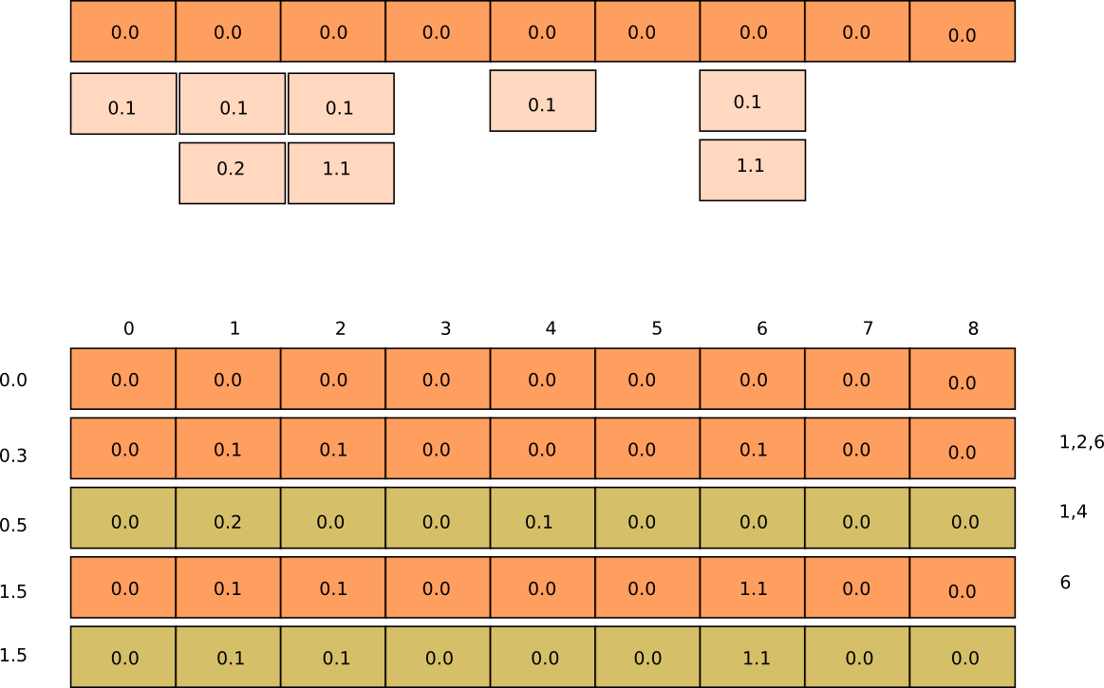Illustration 3: Version Control Model in GNOWSYS. The top horizontal set of boxes represent the nine fields of an object and the version number corresponding to each at the time of creation. The boxes beneath in lighter color are the changes made to each field. The bottom part of the illustration displays the five snapshots of the object. Three of them are changed by the creator of the object, while two others in the alternate color are by another user.
The Illustration 3 is an example of an object's history with about five snapshots of the object. The object underwent one committ and five changes. In the second transaction the user changed the fields 1,2, 6 of the object, hence the change number then is 0.3. Later another user makes a change to the object at fields 1,4, making the change number 0.5. Since the first user did not make any commits after creating the object, the second user does not see 0.3, but only 0.0. Later the first user makes a commit at the field 6, to make the version 1.5. The second user now sees the changes committed by the first user. Each of the snapshots will be stored in the form of a list, in the list field of the object.
Keeping such detailed snapshots of each node of the network provides a unique mechanism to see the various changes. We can get detailed state changes of the object, and its history, and can retrieve given the change number the snapshot of the object at any time.
The third item in the value field of the version number keeps the field numbers modified. This information will come in very handy under three situations. One, for highlighting the part of the data modified. Two, when a version of an object should be deleted, it can be achieved by removing only those fields that are indexed in the third item. Third, if we wish to inspect each state of the object, during the course of its history, the values of the changed fields only need to highlighted, producing a visual graph displaying the modifications.
Another important consequence of this model of representing the changes is its economy of space required in keeping backups. If an 80MB document is modified, and the modification consists in merely a change in the title, keeping the backup and the recent version is very expensive. Since the knowledge in GNOWSYS is highly granular and all the granules are packed together as a package, the entire package need not be taken a backup, but only the modified field.

Illustration 6: An example of a course (on Whale) has relations and attributes set in the knowledge base, and how they are stored. There are five relations in the relations field networked with the five corresponding relation nodes. Similarly the attributes are networked with the attribute node.

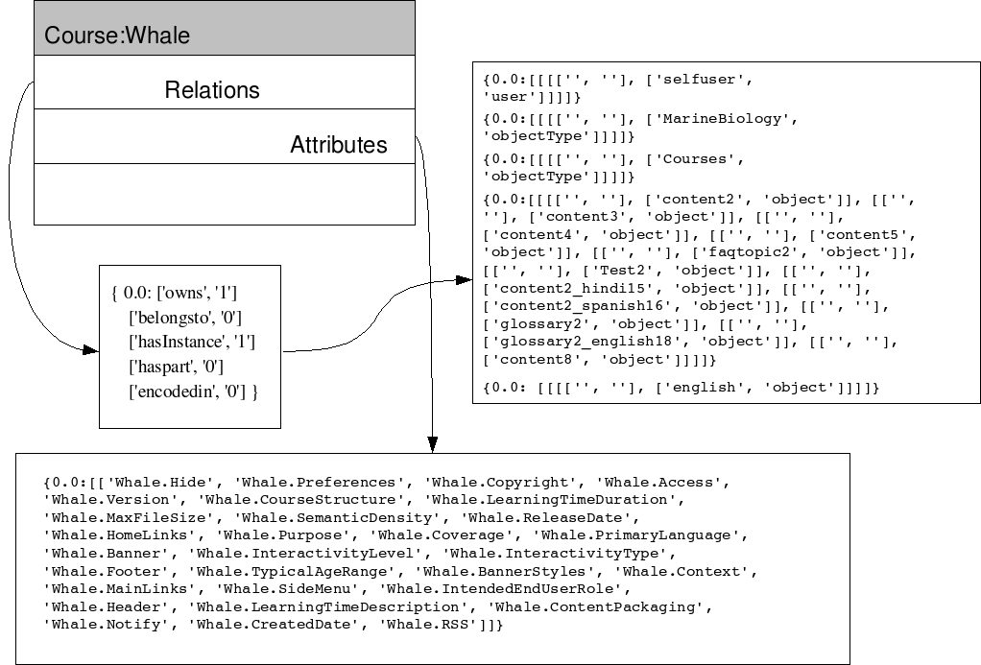Illustration 5: The class node 'Courses' is made, among other metadata, with relation types and attribute types. The illustration shows how the data is stored in the knowledge base defining the schema of a Course.
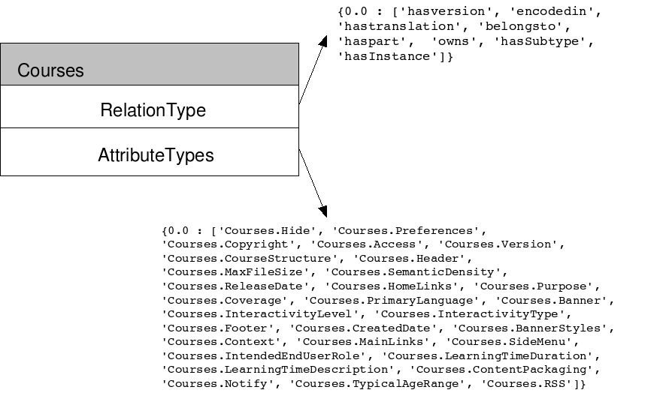Illustration 4: The class node 'Courses' is made with, among other metadata, relation types and attribute types. The illustration shows how the data fields of relation type and attribute type are encoded as a dictionary data type.

GNOWSYS for the SELF Platform
In this section, we list the special features specified in the Platform Definition that need a distributed networking system like GNOWSYS.
- Distributed Knowledge Base
- Semantic Web Ready
- Flexible, Arbitrary (User) Organization
- Semantic Search
- Contextual Menu
- Reuse of a lessons, questions, FAQs, etc. from one course in another.
- Collaborative web based authoring
- Version control of both data and metadata,
- P2P based Distribution and Delivery of Content
- Delivery in Multiple Formats

Translating Platform Definition into Implementation Design
Based on the high level specification of the platform definition (D5) we can draw a list of features and the required implementation design. The presentation below follows a style of formatting to make the purpose of each section clearer. Each section below describes a feature in a summary form, followed by a paragraph describing the design and implementation, which is displayed in Type Writer font.

Creation of the Initial Knowledge Base and Basic Data Model
As defined above in the section, the knowledge base of SELF Platform will be implemented using the nine node types of GNOWSYS. At the time when the SELF Platform is initialized, the data model of the application (schema) will be constructed with almost no data. This data model in a sense constitutes the basic ontology of a teaching and learning environment. To ensure that the knowledge base of the Platform can be ported to other elearning environments, we followed, as specified in the earlier documents as elaborated by the Learning Standards Expert Group, we follow Dublin Core Metadata for content objects, LOM for learning objects, and SCORM for the interrelationships between the learning objects. The following table specifies the objects to be created when an instance of a Platform is made.
Users initiate the creation of several elements into the knowledge base through the Platform's user interface: Course Categories, Lessons, various kinds of Part materials, comments, relations between the learning objects, translation relations, language encoding, creating an account for themselves, changing passwords etc. We are not giving an exhaustive list here, but more detailed descriptions of what happens to the knowledge base when each action is taken are elaborated while describing the implementation details.
Node Types | Objects in the Knowledge Base
Metatypes | Course Type, Lesson Type, Question Type, Test Type, FAQ Type, Glossary Type, Part Material Type, News Type, Bibliography Type, Role Type, Hyperlink Type, Language Type, Comments Type, BookShelf Type, Collaborator Type, Message Type
Classes | Lessons, Questions, Tests, FAQs, Comments, UserType, References, Links, BookShelf, Collaborator, SCO, Course Material, Course, Course Enrollment, Part Material, Content, FAQ Topics, FAQ Entries, Glossary, Link Categories, Links, Tests, Test Questions, Test Results, Test Answers, Test Groups, Test Questions Associations, Objective Questions, Multiple Choice Questions, True False Questions, Descriptive Questions, Languages, Language Text, Feeds, Poll Members, Member Track, Forums, Forum Subscription, Forum Thread, News, Related Content, Themes, Resource Categories, Resource Links, Backups, Messages, Polls, Course Stats, Handbook Node,
Objects | No factory objects created
Relation Types | part of, sub type of, author of, translation of, prerequisite of, instance of, has License, shares, question of, FAQ of, lesson of, test of, collaborator of, message to, message for, message cc,
Relations | Several relations are automatically created, this list is not exhaustive.: Author is an instance of Role Type, Student is an instance of Role Type; Urdu is an instance of Right-to-Left Language; Book is an instance of Bibliography Type; Events is an instance of News Type; MCType question is an instance of Question Type; Activitities, Narratives, Experiments, Illustrations, etc. are instances of Lesson Types, and so on.
Attribute Types | A Large Pool of reusable Attribute Types are created:  Date, File Size, System File Name, File Name, Contents, Ordering, Last Modified, Revision, Formatting, Release Date, Keywords, Content Path, Text, Inherit Release Date, Interactivity Type, Interactivity Level, Semantic Density, Learning Time Duration, Learning Time Description, Content Packaging, Access, Created Date, Notify, Max Quota, Max File Size, Hide, Preferences, Header, Footer, Copyright, Banner Text, Banner Styles, Primary Language, RSS, Home Links, Main Links, Side Menu, Release Date, Banner, Interactivity Type, Inter activity Level, Semantic Density, Intended End User Role, Context, Typical Age Range, Learning Time Duration, Learning Time Description, cost, Coverage, Version, Purpose, Course Structure, Name, Revised Date, Approved, Question, Answer, Language Code, CharSet, Direction, Reg Exp, Native Name, English Name, Owner Type, Name, Url, Link Name, Approved, Submit Name, Submit Email, Submit Date, Hits, Website, first Name, middle Name, last Name, DPB, Gender, Postal, Province, Preferences, Creation Date, Language, Inbox Notify, Private Email, street Address, phone, email, city, country, Type, Feedback, question, Choice0, Choice1, Choice2, Choice3, Choice4, Choice5, Choice6, Choice7, Choice8, Choice9, Answer0, Answer1, Answer2, Answer3, Answer4, Answer5, Answer6, Answer7, Answer8, Answer9, Properties, Weight, Ordering, Format, Start Date, End Date, Randomize Order, Num Questions, Instructions, Result Release, Num Takes, Anonymous, Out Of, Random, Difficulty, Word Definition, Option1, Option2, Option3, Option4, Option5, Answer
Attributes | No factory attributes created
User Type | Manager, Author, Editor, Student, Anonymous
User | Only the default user called 'admin' will be created.
Table 4.1: Node Types of GNOWSYS used in SELF Platform, and some of their instances made at the time of making an installation. These are usually called Factory Objects. They provide the schema (data model) of SELF Platform.

Node Types | Attribute Types for Node Types
Backups | Date, File Size, System File Name, File Name, Contents
Content | Ordering, Last Modified, Revision, Formatting, Release Date, Keywords, Content Path, Text, Inherit Release Date, Interactivity Type, Interactivity Level, Semantic Density, Learning Time Duration, Learning Time Description
Courses | Content Packaging, Access, Created Date, Notify, Max Quota, Max File Size, Hide, Preferences, Header, Footer, Copyright, Banner Text, Banner Styles, Primary Language, RSS, Home Links, Main Links, Side Menu, Release Date, Banner, Interactivity Type, Inter activity Level, Semantic Density, Intended End User Role, Context, Typical Age Range, Learning Time Duration, Learning Time Description, cost, Coverage, Version, Purpose, Course Structure
FAQ Topics | Name
FAQ Entries | Revised Date, Approved, Question, Answer
Language | Language Code, CharSet, Direction, Reg Exp, Native Name, English Name
Languages | Language Code, CharSet, Direction, Reg Exp, Native Name, English Name
Language Categories | Owner Type, Name
Links | Url, Link Name, Approved, Submit Name, Submit Email, Submit Date, Hits
Members | Website, first Name, middle Name, last Name, DPB, Gender, Postal, Province, Preferences, Creation Date, Language, Inbox Notify, Private Email, street Address, phone, email, city, country
Test Questions | Type, Feedback, question, Choice0, Choice1, Choice2, Choice3, Choice4, Choice5, Choice6, Choice7, Choice8, Choice9, Answer0, Answer1, Answer2, Answer3, Answer4, Answer5, Answer6, Answer7, Answer8, Answer9, Properties, Weight, Ordering
Tests | Format, Start Date, End Date, Randomize Order, Num Questions, Instructions, Result Release, Num Takes, Anonymous, Out Of, Random, Difficulty
Glossary | Word, Definition
Objective Questions | Option1, Option2, Option3, Option4, Answer
Multiple Choice Questions | Option1, Option2, Option3, Option4, Option5, Answer
True False Questions | Answer
Table 4.2: List of Attribute Types assigned for the Node Types of GNOWSYS used in SELF Platform.

Left Role | Relation Type | Right Role
Learning Object | is part of | Course Materials
Learning Object | is based on | Learning Standards
Learning Object | is written in | Language
Learning Object | is assigned by | Assigned Role
Learning Object | is contributed by | Contributor Role
Learning Object | is targeted for | User Role
Learning Object | is aimed at | Context
Learning Object | has requirements | Technical Requirements
Learning Object | has requirements | Other Platform Requirements
Learning Object | holds | Copyright
Learning Object | is released under | Licences
Learning Object | has references | Reference Materials
Learning Object | is a kind of | Learning Resource Type
Learning Object | is tagged for | Purpose
Learning Object | is classifed as | Taxon
Courses | has part | Course Material
Courses | belongs to | Course Category
SCO | has translation | SCO
Course Material | has references | Part Material
SCO | encoded in | Language
Content | has version | Content
Lesson | subtype of | Course
Author | author of | Lesson
Learning Object (spanish) | translation of | Learning Object (English)
Learning Object | prerequisite of | Course
Student | instance of | Role Type
Test Question | question of | Course / Lesson
Learning Object | FAQ of | Lesson
Test | test of | Lesson
user | collaborator of | Lesson
Learning Object | owned by | user
courses | announced as | news
courses | conducted by | members
courses | encoded in | language
content | generated by | member
members | broadcast | news
members | provides | course statistics
Table 4.3.: List of Relation Types assigned for the Node Types of GNOWSYS used in SELF Platform. Each Relation Types are associated to the Node Types as shown in Left Role and Right Role.

Authoring System
Since the Platform is meant for authors, teachers, learners, publishers, lecturers, professors, the authoring system is one of the core functions of the SELF Platform. Authors can do several actions within the Platform. Creation and validation of content are two most general categories of action. But, these two processes in a collaborative authoring system may have several other derivative actions such as commenting, discussing, rating, translating etc.
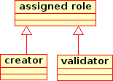Illustration 7: Two main roles authors can be either of the two in an authoring system. The arrow indicates that the bottom class is an instance of the metatype <Role>..

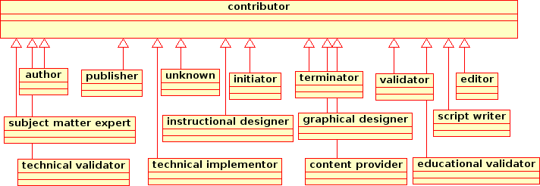Illustration 8: Multiple Roles Contributors can play in the system. The arrow indicates that the bottom class is an instance of the metatype <contributor>.

Creating Content Items
The following procedure provides an example of how each of the items are created and networked with each other within the knowledge base.
- course category: create a <class> node by collecting the <title> and <description>; create a <sub-type-of> relation if another course category is selected; with the <attribute node> <creation time>,
create an <author-of> relation with all the objects and relations that get created during this transcation; set the <language encoding> relation based on the default user's preferences; set the <media-type> of the content; set the <version> to <key> 0.0, and <snapshot value> to each field as 0.0; set creation date-time; (The italicized portion describes the kind of actions to perform while creating any objects.)
- courses: create an <object node> with an attribute type <structure>; create an <instance of> relation with the selected or context defined class node #Course; create a relation node <belongs to> with #courseCategory;
- lessons: create an <object node> with a <relation node> <part of> set with one or more courses selected; with a <relation node> <instance of> set with <class node> lesson.
- FAQ: create an object node with relation node <instance of> set with class node <FAQ> with the selected FAQ category class node; create a relation node <faq of> with selected object learning object/s.
- glossary: create an object node with relation node <instance of> set with class node <glossary>; with selected glossary category class node; create a relation node <glossary of> with selected object learning object/s.
- test: create an object node with relation node <instance of> set with class node <test>; with selected test category class node; create a relation node <test of> with selected object learning object/s.
- question: create an object node with relation node <instance of> set with class node <question>; with selected question category class node; create a relation node <question of> with selected object learning object/s.
- comments: create an object node with <instance of> relation with <comments>; create a relation <comment of> with the object selected or context defined in the content type object;
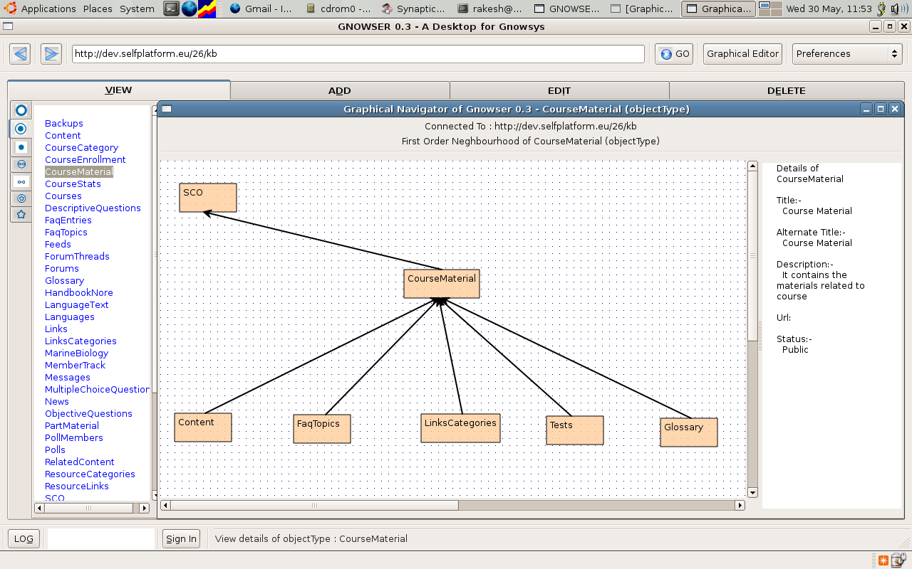Illustration 9: Screenshot of the application Gnowser, which connects to the knowledge base of GNOWSYS, and displays graphically the network nighbourhood of the selected node. In this case it displays the the five different kinds of 'course material' as subtypes, and the class node 'course material' is a subtype of the class node 'SCO'. Gnowser is emerging as a gnowledge browser meant to navigate all the distributed knowledge bases in the cyber space, and network, manage, and organize the distributed resources.

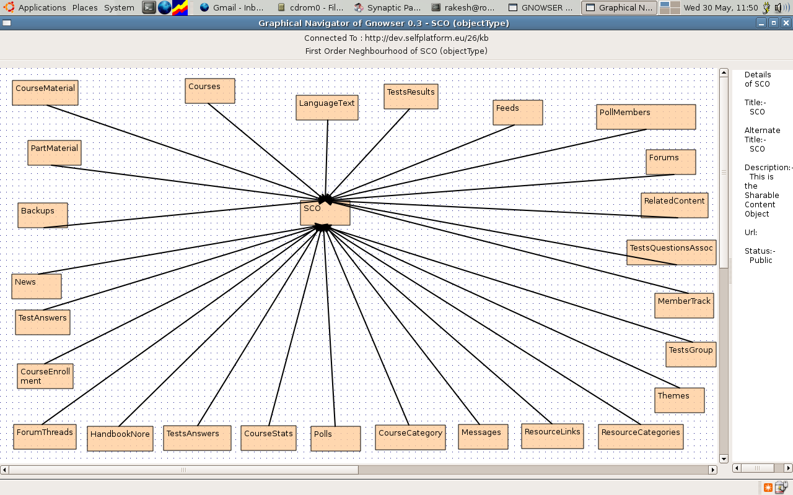Illustration 10: Screenshot of Gnowser connected to http://dev.selfplatform.eu/26/kb/, displaying the network nighbourhood of the main class node SCO.
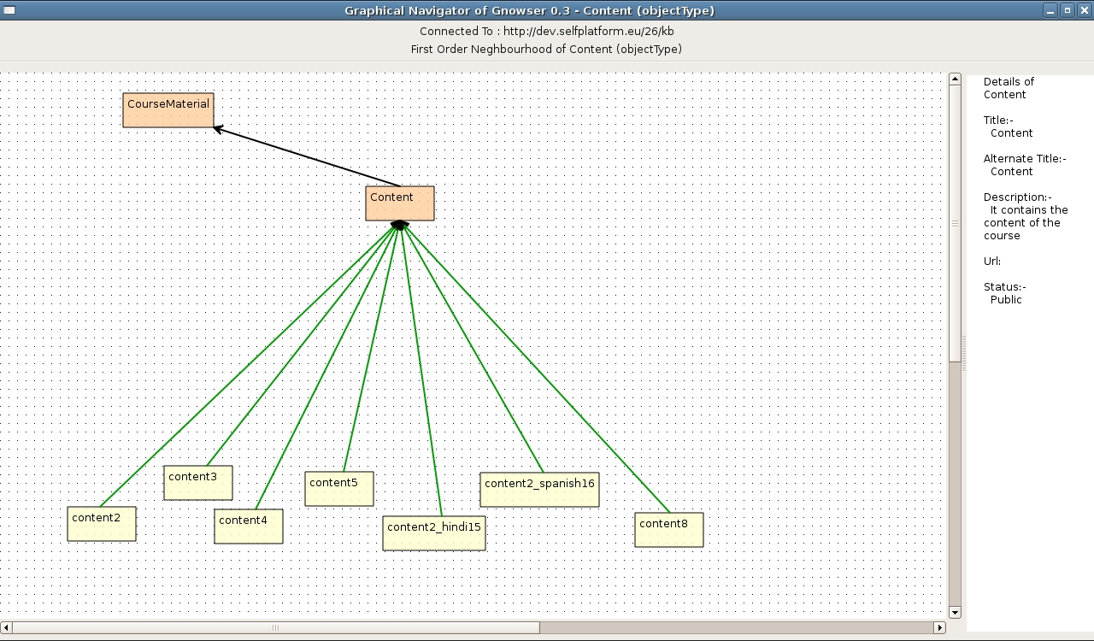Illustration 11: Screenshot showing the seven instances of the class node 'content', which is a subtype of 'Course Material'.

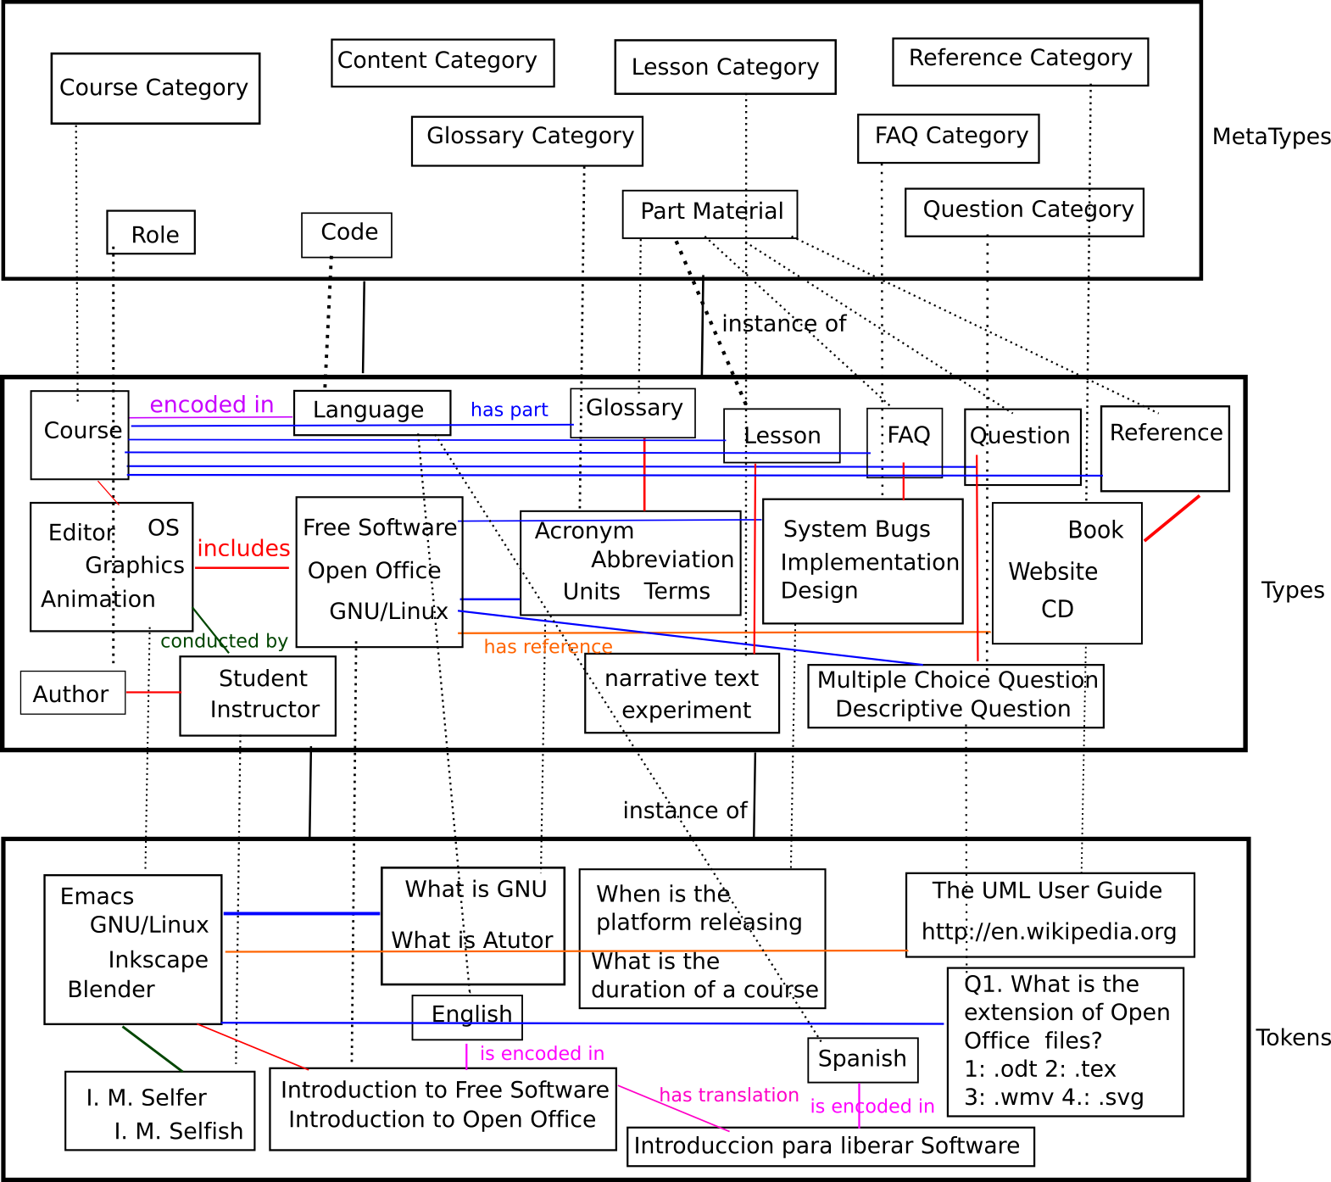Illustration 12: The illustration depicts how the various kinds of objects in the knowledge base of the platform are grouped and related according to the GNOWSYS specification. The dotted lines represent 'instance of' relation. Metatypes help in organizing the various kinds of courses and their part material shown in the middle type layer. The bottom layer shows the actual data.

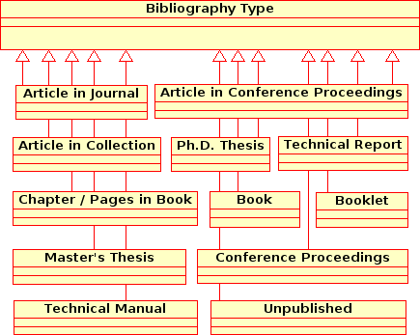
Illustration 13: The part material references can be further classified into various kinds of documents. The instances of these type of bibliography types will be networked with different learning objects by the relation node <has reference>. These instances can be reused across courses, that a book Emacs Manual may be referred in the course on Programming Environments, as well as Editors. can have a reference relation with the book. The arrow indicates that the bottom class is an instance of the metatype.

Shelf Management
A Shelf is to help the author to keep the selected objects from the knowledge base, for editing, composing a course, traslating, collaborating etc. SELF Platform proposes to have multiple shelfs. Users can add a Shelf, by giving it an arbitrary name (#bookShelf).
- Create a class node <bookShelf> with relation node <instance of> <ShelfCategory>;
- Create an object node #bookShelf with relation node <instance of> with class node <bookShelf>; with relation node <has Shelf> with the user node #user;
- Create a relation node <item in BookShelf> with subjects object node #learningObject and object node #bookShelf;
4. Create a relation node <bookshelf of> with user and bookself
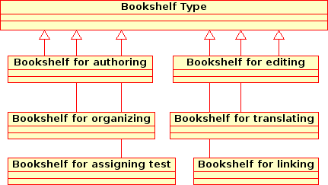Illustration 14: Authors can add arbitrary bookshelfs, but desirably classified into one of the above kinds. The arrow indicates that the bottom class is an instance of the metatype <BookShelf>.

Collaboration
Collaboration enables two or more authors to work together on the same project. It is implemented by creating a class Collaborators. Each user can be assigned a Collaborator Shelf, where the users, who modify and commit the content, automatically becomes collaborators. To enhance the collaborators' experience, they can send messages to each other. These messages appear as Talk page. Comments can be read by everyone, while messages are seen only by the collaborators.
- Create a class node <CollaboratorShelf>; with relation node <instance of> <ShelfCategory>;
- Create an object node #CollaboratorShelf with relation node <instance of>; with class node <CollaboratorShelf>; with relation node <has Collaborator>; with the user node #user;
- Create a relation node <in BookShelf>; with subjects' object node #learningObject and object node #bookShelf; Create a class node <Collaborator>;
- Create an object node #message with relation node of <message to>; with the user node #user.
Alternate implementation of Collaboration can be by invitation and acceptance, which is not difficult to implement, since we already have a message system in place. Since SELF Platform is a community portal, as much like Wikipedia, it is desirable to reduce the number of hurdles before one can begin to contribute. As soon as some one makes a contribution, they will become a collaborator with respect to the current context.

Harvesting
Harvesting is the process of collecting useful free knowledge from other sources of the cyber 'field', and filling the knowledge base with them. Objects collected by this process will be maintained separately on another instance, and will be retrieved by the authors through the search interface. If authors are interested in the harvested objects, they will be added to the Shelf, and integrate with the courses. SELF platform provides two ways of collecting them: semi-automatic and manual harvesting.
The harvesting process identifies a portion of the source document, and designates it as a learning resource, provides a title, and organizes it either as a module, lesson, or lesson component or part material. This applies to both kinds of harvesting.

Semi-automatic Harvesting
There are a large number of structured knowledge bases available from other portals like TLDP (The Linux Documentation Project), Wikipedia, Wordnet etc. TLDP documents are also available in LaTeX as well as SGML markup (DocBook format). Similarly Wikipedia articles are also structured into sections and subsections, taxonomy, attributes, language information etc. Software documentations like Unix manual pages and texinfo documentation pages are highly structured documents. The structure in them provides sufficent semantics so that their components can be inserted into the knowledge base by scripts by parsing the documents. Gnowledge.org already contains harvested content from Wikipedia, which will be available to authors for adoption.
Automatically harvested objects may not be usable directly in the SELF Platform. This content will act as seed content for authors, or reference material. Transforming them into usuable course form requires contribution by authors. Further processing happens through atomiser, described in section.

Manual Harvesting
Unstructured free knowledge available in the form of text files, HTML files, PDF files, ODT files, cannot be automatically parsed for semantics. Such files will be uploaded to the SELF platform through the regular file upload function. The information in such files can be used for course construction only after breaking the document into meaningful parts, and also adding the semantics manually. We call this process “atomising”. The atomiser functionality is described in the next section.

Atomiser
It is desirable that each learning activity meets a single objective. Transforming existing course content into small content objects will be one of the activities that the authors will be engaged in. atomised resources also enhance the possibility of reusability in several other courses.
The atomiser works as follows:
- An author chooses one of the uploaded documents that requires to be broken down into usable learning experiences with specified learning objectives.
- The document appears in one frame of the UI, say on the left side of the browser.
- The author locates most likely a small portion, a sub-sub-subsection from the source documnet, and selects the text area.The selected area will be added into the BookShelf preferably named as atomiser.This process of 3 and 4 continues till all the components are harvested.The author organizes the atoms and gives it structure similar to the following:
Module 1
|-Section 1
|--Subsection 1.1
|--Subsection 1.2
|-Section 2
|--Subsection 2.1
|---Subsubsection 2.1.1
|---Subsubsection 2.1.2
|--Subsection 2.2
|--Subsection 2.3
@
The leaf nodes of this heirarchy usually contain the learning experiences. The structure among the items will be collected as the default navigation and sequencing order and will be stored on the system node. The default navigation sequence will be stored in the structure field of the system node in the form of a sequence of ids. For the above example, the structure will be as follows:
[Module 1
[Section 1
[Subsection 1.1
Subsection 1.2]]
[Section 2
[Subsection 2.1
[Subsubsection 2.1.1
Subsubsection 2.1.2]]
Subsection 2.2
Subsection 2.3]]]
Each node of the hierachy will be added as a system node, and all the nodes will be serialized into a sequence and will be stored in one system. Such as master system that holds references to other systems within, will have a relation <basicSequence of> a course. Please see sequencing details in the section 4.7.
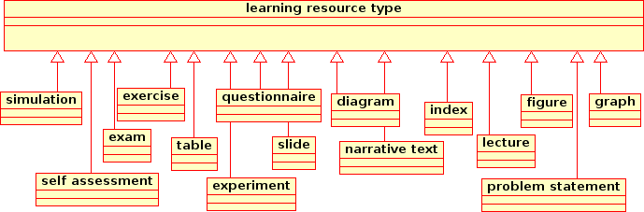Illustration 15: Apart from the major categories into which courses can be classified, each learning experience is often named according to the kind of resource. One of the guiding principle while atomising a course can be to mark the resource appropriately. Guiding principle for each atom is that it provides a unique learning experience, and must have a clear objective. The arrow indicates that the bottom class is an instance of the metatype.

Course Organization, Sequencing and Navigation Definition For the SELF Platform
The Platform Definition provided only a high level specification that the SELF Platform will have a facility to organize course trajectory. However, since the specification demands that the SELF Platform be LOM and SCORM compliant, the detailed specification is drawn from these standards. The following details are essentially implementation details of the SCORM 2004 standard.

Default Sequence and Navigation
The default course navigation is the basic content organization as described in the section atomiser . In the absence of advanced or adaptive sequence relations this structure will be taken as a guide while navigating the course.
Since the authoring environment in the SELF Platform is a crucial part, the main course navigation support will be the default sequence.
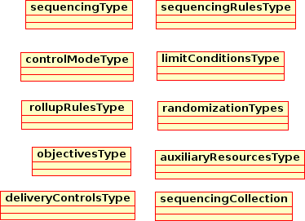Illustration 16: Adaptive sequencing, rollup and navigation requires the above mentioned nodes. These are as per the SCORM 2004 specification.

Advanced (Adaptive) Sequence, Navigation and Rollup
Adaptive or advanced sequence definition is one of the most complex, but very useful set of metadata applied to an activity. A Learning activity, according to SCORM 2004 specification can be described as a “meaningful unit of instruction” any collection of that can be together grouped, given the basic sequence, and is intended to meet one of the course objectives. An activity may also be comprised of other sub-activities in a hierarchical manner.
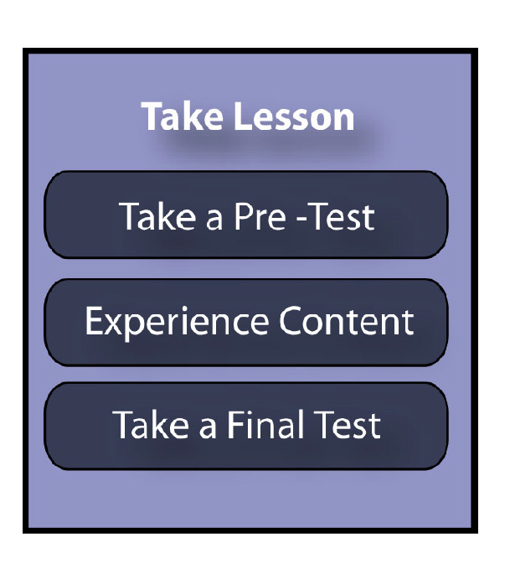Illustration 17: An example of a learning activity. Source from ADL, SCORM SN Book 2, Figure 2.2a.
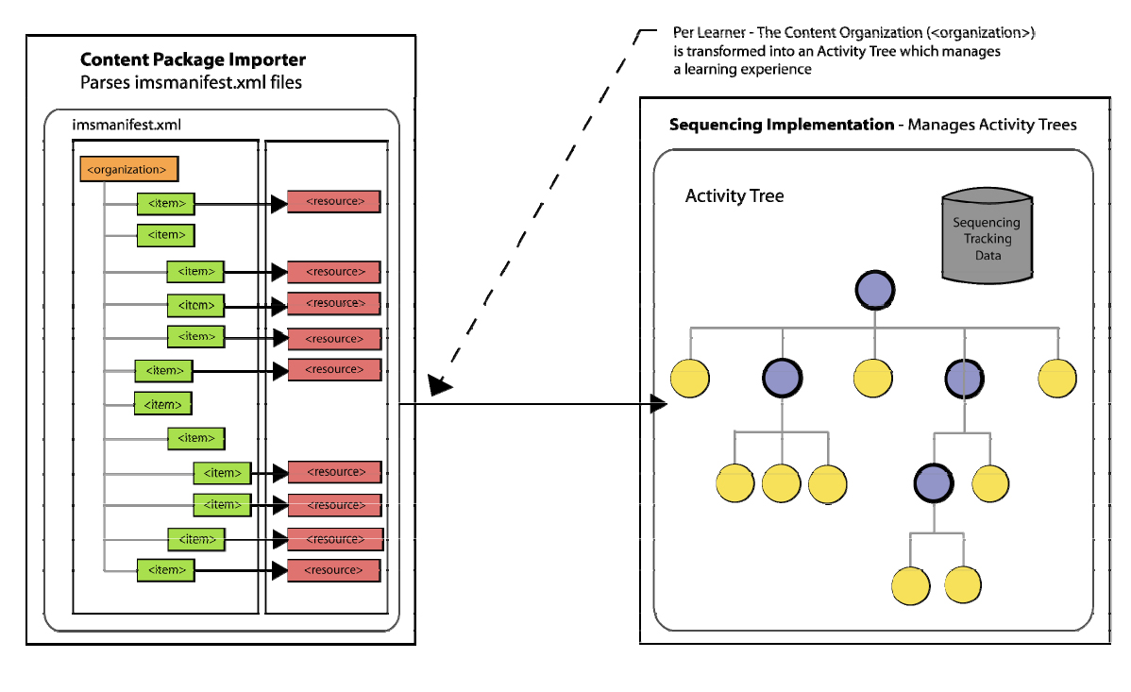Illustration 18: The relationship between the basic default sequencing and the activity tree. Source from ADL, SCORM SN Book2, Figure 2.1.1a. Copyright ADL 2004.
In the SELF Platform, each parent node will be implicitly taken to be an Activity, unless otherwise specified. Thus for each parent node, the author can apply the adaptive sequencing metadata.
The rules defined to each activity will form the navigation model for each course. The entire definition will be collected as in the nodetype <system> of the GNOWSYS knowledge base.
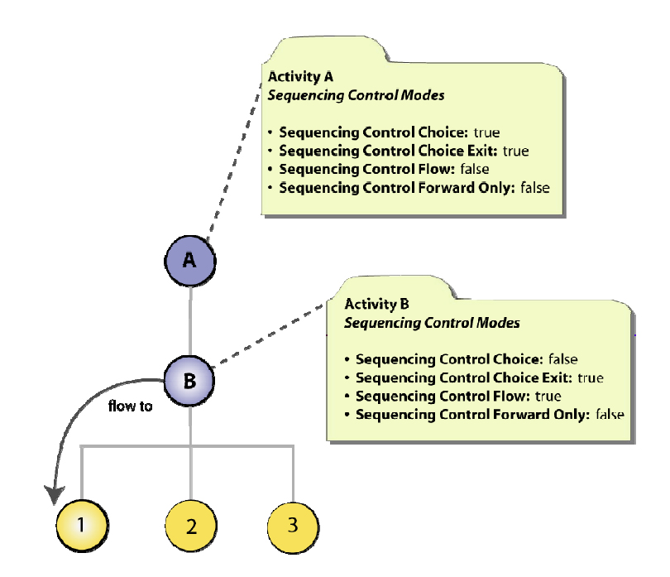Illustration 19: Activity node will have the metadata suggesting 'Sequencing Control Flow = true', therefore the learner will be delivered the objects in the sequence. If it is set to false, the learner has the choice to do any of them in any order. Figure source from ADL, SCORM SN Book2, Figure 3.2.1b. Copyright ADL 2004.
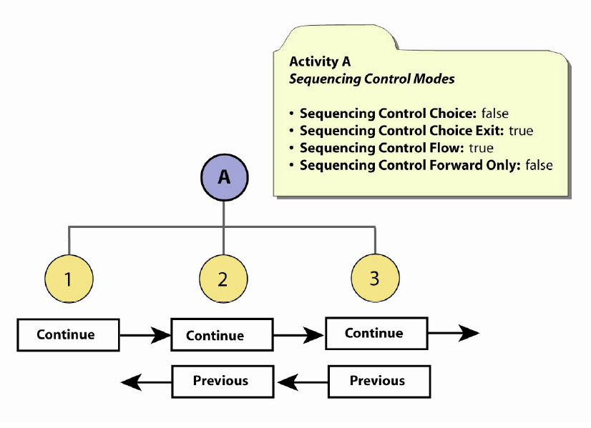Illustration 20: In this case, by setting the variable 'Sequencing Control Forward Only = false', the author informs the LMS that the learner has the freedom to go back and forward. If this variable is set 'true', backward navigation will be disabled by the LMS. ADL, SCORM SN Book2, Figure 3.2.3a. Copyright ADL 2004.

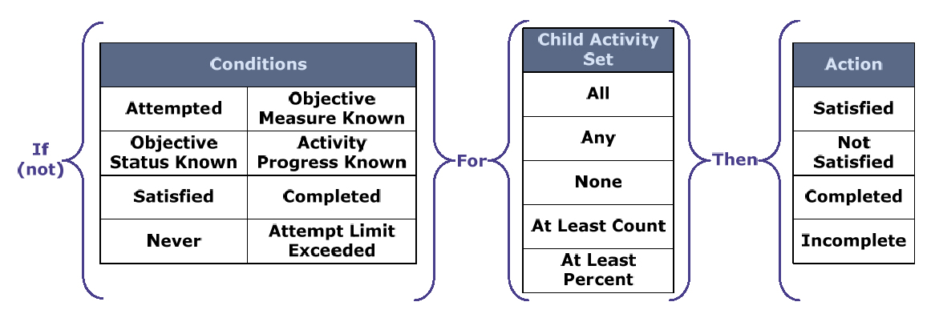Illustration 21: The Rollup Rule Conditons Child Activity Set and Actions. ADL, SCORM SN Book2, Figure 3.7a. Copyright ADL 2004.
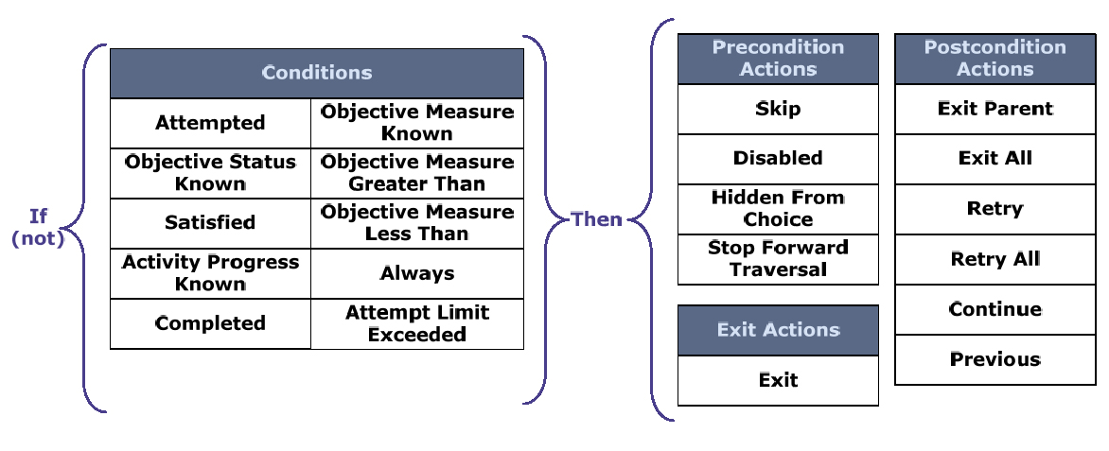Illustration 22: Sequencing Rule Conditions and Actions. ADL, SCORM SN Book2, Figure 3.4a. Copyright ADL 2004.

A system node is an organizer node. GNOWSYS contains a special field called 'structure', which holds essentially the sequence of nodes. One of the nodes in this seqeunce can also be a system node. Thus nested structure is obtained. A hierarchical structure can be defined using this organizer node.

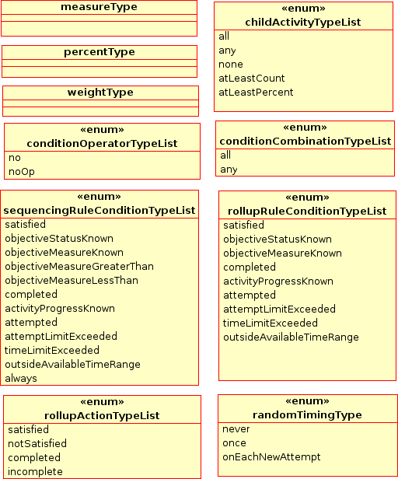Illustration 23: The illustration shows the special datatype classes useful for defining the advanced sequencing rule conditions, rollup actions, rollup conditions, condition combinations, etc. All these are used as special attribute values while defining the sequencing and rollup rules.

Embedded within this sequence some of the nodes will specify a sequencing rule, sequencing rule action or a rollup rule. Sequencing rule objects are described in the illustration 49. The order is very similar to the way an XML file serialises different elements and embeds sub-elements within. Structure node in GNOWSYS will be isomorphic to the standard XML definition of each document encoding. It can be SCORM, ODT, OWL, or any such document encoding specification.

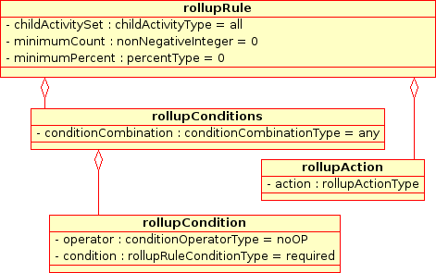Illustration 24: Course Rollup rules specifiable by the authors. Rollup rules help in aggregating the learners behavior and adaptively modifying the navigation. As the learners are experiencing, the course, their actions and results are tracked, and passed on to the parent nodes, informing the navigator the results of taking a course. When all the activities are experienced by the learner the course sort of rolls up. In the SELF Platform, these conditions are applied to the parent nodes of activities. Rollup actions are also classified as pre, post and exit as in the sequencing rules.

Classification of Resources
Classification of the resources can be made according to the standard schemas suggested by LOM and SCORM, as well as user defined categories. Network model of SELF platform is eminently suitable for organizing the same resources in multiple ways.

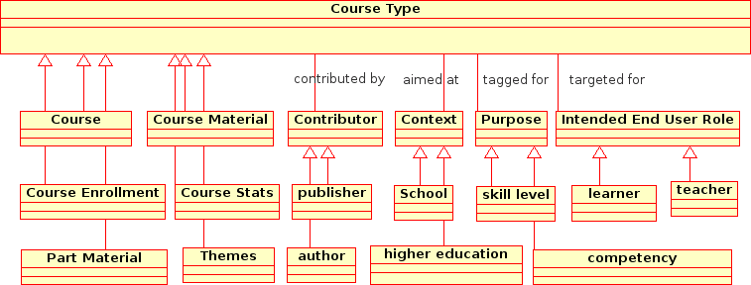Illustration 25: Courses can be classified according to predefined ways, as well as arbitrary tags the users of the platform suggest. All these will be implemented by defining the appropriate relations. The arrow indicates that the bottom class is an instance of the metatype <Course Type>.

Illustration 26: Shareable Learning Objects can be classified as above. A course depending on the kind of objectives will have a few of the above kinds of learning objects. These will be implemented by establishing the relation node <subType> between the above types, and node type <instanceOf> will be used between the specific learning object and the type. The arrow indicates that the bottom class is an instance of the metatype <learning resource type>.

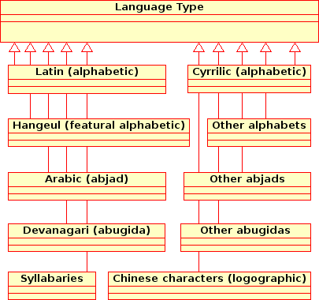Illustration 27: Specific languagess will be made as instances of the above language types. The arrow indicates that the bottom class is an instance of the metatype <Language Type>.

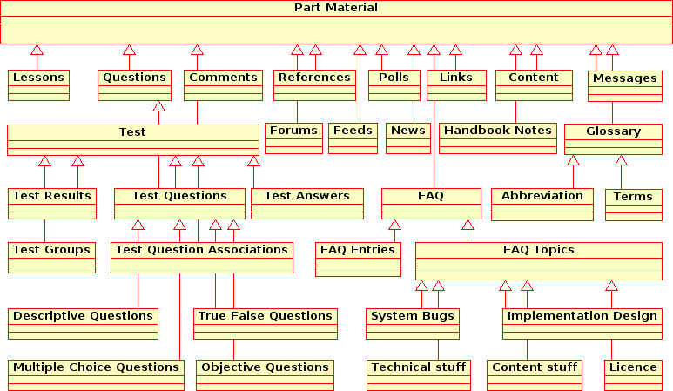
Illustration 28: Various Kinds of Part Materials in SELF Platform. The arrow indicates that the bottom class is an instance of the metatype <Part Material Type>

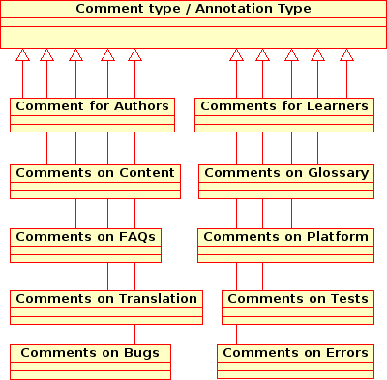Illustration 29: Classification of comments based on the kind of resource, and intended use.

Version Control
All changes to the knowledge base will be marked either as changes or as committs. Unless modifications are committed, other users will not see them. The changes and committs will be recorded in the knowledge base by the version control enabled instance of GNOWSYS. The default change management policy will be applied to all metadata, as explained in section 3.2.
The main body of the lessons or courses, and other file types like images etc. are all stored external to GNOWSYS. For the Phase I of the SELF Platform, such files will be saved in Plone. Each modified version of the file's URI will be entered in the 'Path' field of the nodes in GNOWSYS, with the number computed as mentioned in section 3.2 For the Phase II of the SELF Platform, at attempt will be made to store all the media files other than text, HTML format out of the database (that is in a file system). This will reduce the load on the database, as the platform begins to unfold and becomes more active.
For the SELF Platform, we adopt the policy of prunning the changes of the current user for every commit. If due to some reason a committed version should be deleted, say due to insertion of objectionable content, from the knowledge base, the first option will be to make that version of the object invisible. Just in case that version be removed, it may be done without any change in the operation.
Prunning a changed version and deleting a committed version will be carried out by the same function, because each version has a distinct key, and the deletion effects only the modified fields, keeping other fields intact.

Keeping history
All committed changes from the day of the final launch of the portal will be maintained. Users can view the older version of an object by selecting it. This will trigger a retrieval call of the version by using the unique version number in the form of a complex structured sequence of numbers picking the exact snapshot from the history. Since this is like any normal retrieval of content from the knowledge base, it does not involve any special computation, and will not take more than normal time.

Tracking and Record Keeping
A special class will be maintained in the knowledge base that will keep the use, change numbers, objects changed, for each transaction. Since, the knowledge base uses a networking model, usually every transaction changes more than one node in the network. Thus, whenever an object is modified, user records are also modified.
Only the modifications are tracked for the authoring system of the SELF Platform. Retrieval does not trigger any records to be kept in the knowledge base. Thus each access of the knowledge base does not modify the nature of the knowledge base.
However, if SELF Platform evolves later as a Run Time Environment, delivering courses, then each and every access is required to be tracked. SCORM 2004 specification provides the schema for implementing such a feature. These records are used in tracking the progress of learners.

Comparing versions
The users of the SELF Platform can select any two versions of the same object, and compare the changes. If the comparison is between a committed version and changed version, an option will be provided for prunning the changed version, if the changed version is owned by the user.

Branching
Branching happens implicitly for each committ of changes. When a translation is attempted, or when changes of educational context, level, purpose are made, a new trunk is created.
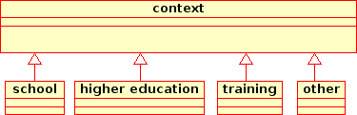Illustration 30: Each content object must be authored keeping in mind the educational context. The platform supports branching a course from one context to the other, so that by making suitable modifications, the content can be adapted to other educational goals.

Rating and Crediting System
User and content rating and user rating will be implemented based on a number of measures that the knowledge base accumulates. Since there are several ways of computing, this will remain an open ended problem. As and when we find a useful model of measuring, an implementation will be attempted. Currently our focus is on trying to keep all the useful records which can be used to compute the rating and credits.
The user rating model in SELF Platform mostly happens by what an author does in the system. Though user rating can also be made by user's feedback, more reliable rankings can be generated by
constructing the profile of the users. This kind of passive rating happens due to highly structured semantics of the knowledge base. First, SELF Platform keeps track of every change made to the knowledge base. Second, the change is always made to a category of an object, say to atomiser, editing, creating new objects, adding categories, translating, organizing, sequencing, editing metadata etc. Third, the change is made to a particular kind of field of the knowledge base, say to relations, attributes, or content etc. All this information will be very useful in generating a profile of each user, and such user profiles can be used to rate the users. A user may be good in writing good content, but may not be very good in defining the sequence, navigation controls, and rollup rules. Another user may be good in doing the latter and not the former. Based on the creator of such data, we can distinctly credit users. Thus, even though a author does not explicitly say that he is a translator, by the nature of the changes the system will infer as a translator.
SELF Platform's rating is not confined to users, but also of the content. When an object created by a user, is not used in any course, the rating will fall not only of the users, but also of the content. If a learning object is used in more than one course, its rating will be high. In a network based storage, computing the number of relations with other objects, and to which kind of objects is straight forward. If the reputation of a content is high, obviously the reputation of the authors will also be.
Volume of each user's contribution will be computed by measuring the amount of change. Amount of change can also be on the bases of the size of change, the number of words, and the number of insertions. Most direct calculations will be updated for each commit/change.

In a collaborative environment, more than one user often contributes to an object or to a course. So SELF Platform keeps the record of who created the object, who contributed to the object. All the users will be credited by announcing them to authors.
Based on the time the user logs in and logs out we will record the duration of each session. And the changes made in a given duration can be added up to assess the kind of usage of the system.
The Shelfs in the platform also provide useful information. How many times a user enters into the User Shelf of a course will tell the user's collaboration profile. And how many of the user's articles find their way in other users's book shelf.
All such computations, and possibly several others can be carried out. As mentioned earlier, as and when a clear model to compute is known, we will make all efforts to implement.

Translation
One of the main activities envisaged on the SELF Platform is translation of content from one language to another. Each user can select one main language and a few other languages as secondary. This stored configuration will help us to compute the list of languages for selection when a user intends to translate an object.
Translation is required for three different kinds of layers of the Platform.

Content
Every content object has two language specific relations.
#content object <encoded in> #langauge
#content object <translation of> #content object
The former is made at the time of creating the object, while the latter is made only when an author saves a transaltion. The following procedure is followed for this step:
- create a new sibling object node with relation node <translation of> with the source object.
- warn the user if the object is a course component and if the translation version of the course does not exist, prompting the user to create one.
- if the course object is not created by the user despite the warning, add the translated object into the TranslatorShelf.
- if the course object is created or if already exists, establish the regular <part of> relations with the translated course object of the current langauge.
- each translation creates a new object, therefore will have the version key set to 0.0, and create a relation node <branched from> with the source version of the object.

Metadata
The metadata refers to the names of attributes and relations, such as <branched from>, <part of>, <translation of>. All such metadata used for SELF Platform will be collected into a POT file (Portable Object Template), as per the free software internationalization guidelines. A translation interface for them will be available so that PO (Portable Object) for each language will be created, and will be used for each instance of SELF Platform. Though initially seven languages will be supported, eventually other translations will be applied to SELF platform as and when community contributions are committed to the source tree.
This feature is inherited from the placeless translation package contributed by the Plone project.

User Interface
Similar to the metadata, all messages of the SELF platform will be collected as another POT file, and will be translated to generate PO files for each language.
This feature is inherited from the placeless translation package contributed by the Plone project.

Search
Searching the knowledge base of the varioius kinds of information is part of any web application. The SELF Platform search is enabled by maintaining two catalogs.

One catalog keeps all the natural language content and the other catalog mantains all the metadata of the content. The input string is matched with objects's containing the string, and prioritizes them on
the basis of percent of relevance. The input strings are dynamically expanded while typing, and the objects of higher relevance are shown immediately.

It is thought often that a kind of blind matching of a string strategy is not effective. The SELF Platform provides another search (semantic or advanced) which shows results based on the data model of the SELF Platform. Since the knowledge base of the SELF Platform is implemented in GNOWSYS, which is a semantic web enabled server, users can query based on the semantics used in the data model of the SELF platform.
Traditional databases are accessible only through a CGI application, which in turn makes the queries to the database. This does not expose the data model to the users. Through the advanced search, SELF Platform will let the users look at the knowledge base by the data model.

Advanced search behavior can be as follows: when users do not specify any specific category, the input string will be matched with only the title, description and keywords fields of the knowledge base. This is the default behavior of the advanced search. Later the user can specify, search only among the courses, or only among the Spanish courses, or only among the part material, or among those objects present in the book shelves of the current users, sort objects according to user rating, etc. This search gives endless possibilities to see through the database.

Catalogue

Advanced (semantic)

Delivery
The main objectives of the Platform is to facilitate collection (harvesting) of the available free knowledge resources, create fresh resources, organize them into packages. The packages thus obtained can be distributed in various ways.

Default
Being a web based platform the default delivery of the packages will be an online delivery. A basic default navigation allows the users to go through the content and its organization.

HTML
Each package can be downloaded as a single or a bundle of navigable content in the form of HTML, and other media files that are internally linked.

SCORM
Each course package can be exported in the standard SCORM 2004 format. These files can be played in any standard compliant LMS, such as Moodle, Atutor etc.

LaTeX
Each package will also be exportable as a LaTeX file, or a bundle of LaTeX files.

PDF
The packages will be delivered as a PDF file after processing them from either a LaTeX source of the package, or the HTML source of the package.

ODT
As ODT is emerging as a widely used free document standard, it is highly desirable to have an export mechanism for this format as well. However, users can take the HTML file and then later save them as ODT files, till we find a way of direct conversion.

Docbook
The package content will be exported into Docbook standard format, which can be used by publishers for reuse of the courses distributed at SELF Platform.

Distributed knowledge base
As stated earlier, the knowledge base of the SELF Platform needs not keep all the data in one server. The data can be physically located anywhere on the Internet. A SELF Platform instance can be configured to search the catalogues of a list of servers specified in a list published as instance's property. When a user makes a query, the results will show the objects of all the servers. Since each result (object) has a unique URL, users can access the object, adopt it in the current instance, or make relations with the remote object etc.

p2p service architecture
Exploiting the distributed knowledge base feature, each server acts as a peer to other servers. The servers are configured to each other either as primary or secondary, similar to the P2P architecture of DNS servers. This service works as follows: if a server SP-1 is marked as primary to another server SP-2, whenever commits are made to the knowledge base, the primary server sends a message to the secondary server, and propagates the changes to the secondary server. If the secondary server does not want the entire knowledgebase, the server can be specified to get only courses, say of “computer science”. Since changes are highly granular, it does not create heavy traffic between the servers.

If SP-3 is located in a remote area, and is not regularly connected to the main server SP-1, people can contribute directly to SP2, and when the connection is established, changes from SP-3 will be propogated back to SP-1. The same feature can be used for making backups of knowledge base on a regular basis without any human intervention.

The implementation is a feature available in GNOWSYS, which provides functions like populatePeer, initializePeer, and addPeer.

Accessibility
SELF Platform inherits several good practices of a web application from Plone, which conforms to Section 508 (reference), W3C AA compliance (reference), the SELF Platform will particularly implement Daisy standard for readability enhancement for the blind. The knowledge base of SELF Platform is structured according to the subject-predicate model of first order logic. This enables us to provide special Diasy standard complaint markup so that the page navigation and each block of the text provided with the semantics of the content, helps the blind actually see, as it were, the structure of the document. One of the developers of the SELF Platform is a visually impaired programmer, who will be implementing this feature.

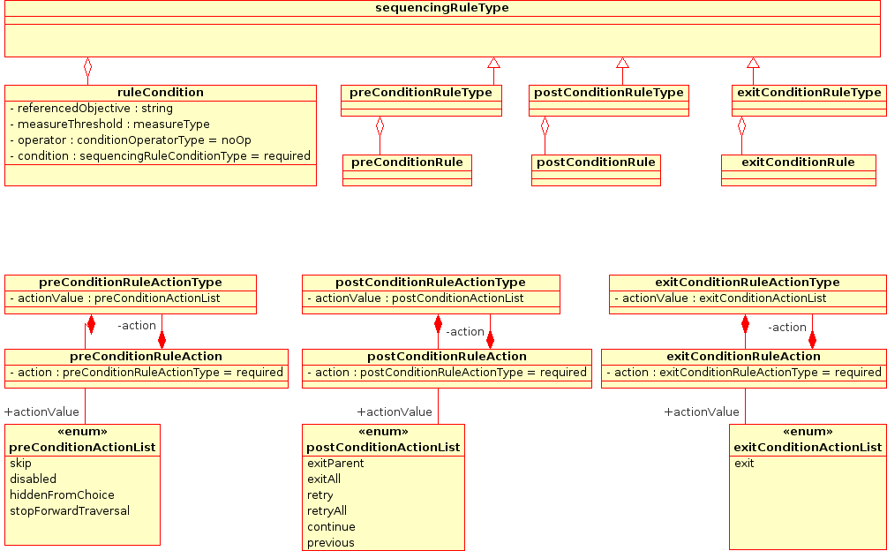Illustration 31: Advanced Sequencing Model of SELF Platform conforming to SCORM 2004 Sequencing rules are defined by setting preconditions, post conditions and exit conditions. Each of the rules inform the RTE, how to behave with the learner. And each of the conditions are mapped to the corresponding actions. The possible actions are enumerated in the 'three separate lists in the illustration marked as 'preConditionActionList', 'postConditionActionList', and 'exitConditionActionList'.

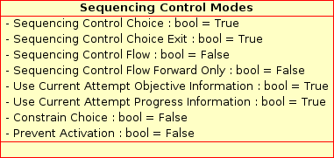Illustration 32: Sequencing Control Modes are applied to activities. These will not have any effect if applied to the leaf node of the basic sequence defined by the organizer.

Glossary

Term | Description and/or references to the terminology
ADL | Acronym for “Advanced Distributed Learning”, an Initiative sponsored by the OUSD P&R of the USA Department of Defence. ADL maintains the SCORM collection of specifications.
CL | Acronym of “Common Logic”, a formal language based on first-order logic, intended to facilitate the exchange and transmission of knowledge in computer-based systems.  http://en.wikipedia.org/wiki/Common_logic
CMS | Acronym for “Content Management System”, a system designed to help users publish content on the web, usually embodying editorial policies and workflows, and unifying layout and design.
CVS | Acronym for “Concurrent Versions System”, CVS is a widely spread version control system published under the GPL license.
DAISY | Acronym for “Digital Accessible Information System”, a standard for Digital Talking Books.  http://www.daisy.org
Distributed Database Management System | A distributed database is a database that is under the control of a central database management system in which storage devices are all attached to a common CPU. It may be stored in multiple computers located in the same physical location, or may be dispersed over a network of interconnected computers.  http://en.wikipedia.org/wiki/Distributed_database
DocBook | A markup language for technical documentation. It was originally intended for authoring technical documents related to computer hardware and software but it can be used for any other sort of documentation.  http://en.wikipedia.org/wiki/DocBook
DTML | Acronym for “Document Template Markup Language”, a server-side scripting language introduced with early Zope versions.
Dublin Core Metadata | The Dublin Core metadata element set is a standard for cross-domain information resource description.  http://en.wikipedia.org/wiki/Dublin_Core_Metadata_Initiative
FTP | Acronym for “File Transfer Protocol”, it is one of the first and most popular high-level Internet protocols, often used to publish large files for public access.  http://en.wikipedia.org/wiki/FTP
GNU | Recursive acronym for “GNU's Not Unix”, a project launched by Richard Stallman in 1984 with the aim of creating a complete computing environment comprised exclusively of free software.  http://www.gnu.org/
GNU arch | A software revision control system that is part of the GNU Project. Since May 2006 the project is maintained but not under active development
HTTP | Acronym for “HyperText Transfer Protocol”, it is the network protocol uses to deliver most of the World Wide Web's content.  http://en.wikipedia.org/wiki/HTTP
IMS | Acronym for “Instructional Management Systems”, a non-profit standards organization concerned with establishing interoperability for learning systems and learning content and the enterprise integration of these capabilities.  http://en.wikipedia.org/wiki/IMS_Global
LaTeX | A document preparation system based on Donald Knuth's TeX typesetting system. It is very popular and widely used for scientific papers in the so-called “hard” sciences.  http://en.wikipedia.org/wiki/LaTeX
LMS | Acronym for “Learning Management System”, a software package that enables the management and delivery of online content to learners.  http://en.wikipedia.org/wiki/Learning_Management_System
LOM | Acronym for “Learning Object Metadata”, a data model, usually encoded in XML, used to describe a learning object and similar digital resources used to support learning.  http://en.wikipedia.org/wiki/Learning_object_metadata
ODF | Acronym for “Open Document Format”, a open standard document file format used for describing electronic documents such as memos, reports, books, spreadsheets, charts, presentations and word processing documents.
ODT | Acronym for “Open Document Text”, the ODF format for storing word processing files.
OWL | Somewhat contrive acronym for “Web Ontology Language” is a language meant to describe and instantiate web ontologies.  http://en.wikipedia.org/wiki/Web_Onology_Language
P2P | A peer-to-peer (or P2P) computer network relies primarily on the computing power and bandwidth of the participants in the network rather than concentrating it in a relatively low number of servers.  http://en.wikipedia.org/wiki/P2P
PDF | Acronym for “Portable Document Format”, a file format used for representing two-dimensional documents in a device independent and display resolution independent fixed-layout document format. Each PDF file encapsulates a complete description of a 2D document that includes the text, fonts, images, and 2D vector graphics that compose the document.  http://en.wikipedia.org/wiki/PDF
PLONE | A free CMS system based on Zope.  http://www.plone.org/
PostgresSQL | PostgreSQL is a free software object-relational database management system (ORDBMS), released under a BSD-style licence.  http://en.wikipedia.org/wiki/Postgresql
RTE | Acronym for “Runtime Environment”, a configuration of computer programs that enables the execution of a given process, as opposed to its development.
SCO | Acronym for "Shareable Content Object" as used in SCORM.
SCORM | Acronym for “Sharable Content Object Reference Model”, a collection of standards and specifications used to encode content for computer-aided instruction systems.  http://en.wikipedia.org/wiki/SCORM
Section 508 | Section 508 requires that all content and services provided by the USA Federal Agencies be accessible by individuals with disabilities. It includes a collection of standards for software applications, web-based content and other ICT products.  http://www.section508.gov
SELF | You really shouldn't be reading this...  http://selfproject.eu
SELF Platform | SELF Platform is an online learning environment with educational and training materials about Free Software and Open Standards. http://dev.selfplatform.eu
SGML | Acronym for “Standard Generalized Markup Language”, a data representation metalanguage designed to be able to specify data representation languages for a wide variety of applications. HTML, XML and DocBook are instances of languages defined in SGML.  http://en.wikipedia.org/wiki/SGML
SOAP | Acronym for “Simple Object Access Protocol”. a protocol for exchanging XML-based messages over computer networks, normally using HTTP.  http://en.wikipedia.org/wiki/SOAP
SVN | Subversion, also referred to as SVN, is a revision control system designed to be a modern replacement for CVS.
URI | Acronym for “Uniform Resource Identifier”, is a structured string that is used to identify a specific resource, such as a file on a web server(http://en.wikipedia.org/wiki/URI), a telephone (sip:+1615555123), a file on the local disk (file:///etc/passwd), etc. Most people call URIs “web addresses”. It is oten used interchangeably with “URL”.
URL | Acronym for “Uniform Resource Locator”, an URI which specifies the means and location of the resource, as opposed to an URN. It is mostly used interchangeably with “URI”.  http://en.wikipedia.org/wiki/URL
URN | Acronym for “Uniform Resource Name”, an URI which may not specify a location where the object can be retrieved.  http://en.wikipedia.org/wiki/Uniform_Resource_Name
W3CAA Compliance | Content is considered W3CAA compliant when it follows the Level Double-A Conformance to Web Content Accessibility Guidelines 1.0 published by the W3C.  http://www.w3.org/WAI/WCAG1AA-Conformance
WebDAV | Acronym for “Web-based Distribution, Authoring and Versioning”, a set of extensions to the HTTP protocol which allows users to collaboratively edit and manage files on remote web servers.
XML | Acronym for “eXtensible Markup Language”, a language designed to represent structured data in a standardized and platform-independent fashion.  http://en.wikipedia.org/wiki/XML
XML-RPC | Acronym for “eXtensible Markup Language – Remote Procedure Call”, a protocol used to access different kinds of services delivered by a server process. http://en.wikipedia.org/wiki/XMLRPC
XTM | Acronym for “XML Topic Maps”, an abstract model and XML grammar for interchanging Web-based Topic Maps.  http://www.topicmaps.org/xtm/
ZOPE | A free application server for building content management systems, intranets, portals, and custom applications.  http://www.zope.org/
ZPT | Acronym for “Zope Page Templates”, a web page generation tool to help programmers and designers collaborate in producing dynamic web pages for Zope web applications.

See the SELF Platform Definition as submitted to the European Commission for review and published on SELF Project: http://selfproject.eu/en/system/files/SELF_Platform_Definition_20070213.odt
http://gforge.org/
http://sourceforge.net/
http://savannah.gnu.org/
The SELF Platform is accepted as a non-GNU project on Savannah and can be found here: http://savannah.nongnu.org/projects/self-platform/
Demonstration version of the SELF Platform: http://dev.selfplatform.eu.
http://plone.org/about/plone
http://savannah.gnu.org/projects/gnowsys/
http://www.gnu.org/software/gnowsys/GNOWSYS_files/cpv2/index.html
See http://selfproject.eu/en/system/files/SELF_Platform_Definition_20070213.odt
See the Learning Standards Expert Group (LSEG) and the selected standards for use in SELF: http://selfproject.eu/en/LSEG and http://selfproject.eu/en/system/files/ir3.1_0.pdf
Final 1484.12.1-2002 LOM Draft Standard: http://ltsc.ieee.org/wg12/20020612-Final-LOM-Draft.html
SCORM® 2004 3rd Edition Overview Version 1.0 DRAFT: http://www.adlnet.gov/scorm/20043ED/Documentation.aspx
Portable Object Template files are explained in the GNU Gettext utility, designed to handle translation files: http://www.gnu.org/software/gettext/manual/html_mono/gettext.html

